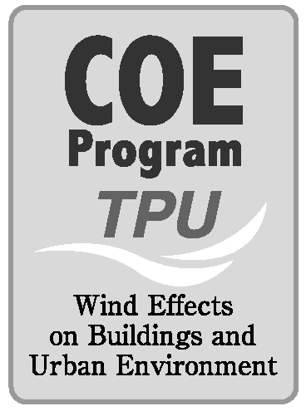

Meeting of APEC-WW
“Wind Environment and Air Pollution”

Tokyo Polytechnic University (Japan)
20 November 2004

Resolutions

Resolution 01
APEC-WW/ WG of ”Pedestrian wind environment” agrees to conduct further inquires to obtain more information on assessment criteria and statutory requirements in APEC countries.
Thermal effects should be considered in the assessment of wind comfort criteria.
APEC-WW/WG will look into the use of peak gust wind speed in both wind tunnel experiments and assessment criteria.

Resolution 02
APEC-WW/ WG of ”Outdoor/Indoor Air Pollution” agrees to conduct further inquires to obtain more information on Environmental Air Quality Standards in APEC countries.
APEC-WW/ WG of “Outdoor/Indoor Air Pollution” agrees to exchange information continuously with WG members in each country.
APEC-WW/WG should concentrate on interactions between outdoor air pollution and indoor air pollution.

Resolution 03
APEC-WW/ WG of ”Indoor Air Pollution” agrees to make an overview document of indoor pollutants criteria and measurement techniques of indoor pollutants (in the future). TPU staff will arrange IAQ information in each APEC country.

